The Befriending Scheme

There have been some changes to our Privacy policy and the way that we collect information on members and volunteers.

Please read the guide below for more information.

Hello, we are The Befriending Scheme (TBS)

We are a Suffolk based charity

We provide friendship and social activities for vulnerable adults
On 25th May 2018, there was a change in the law called ‘The Data Protection Law’ (GDPR) | 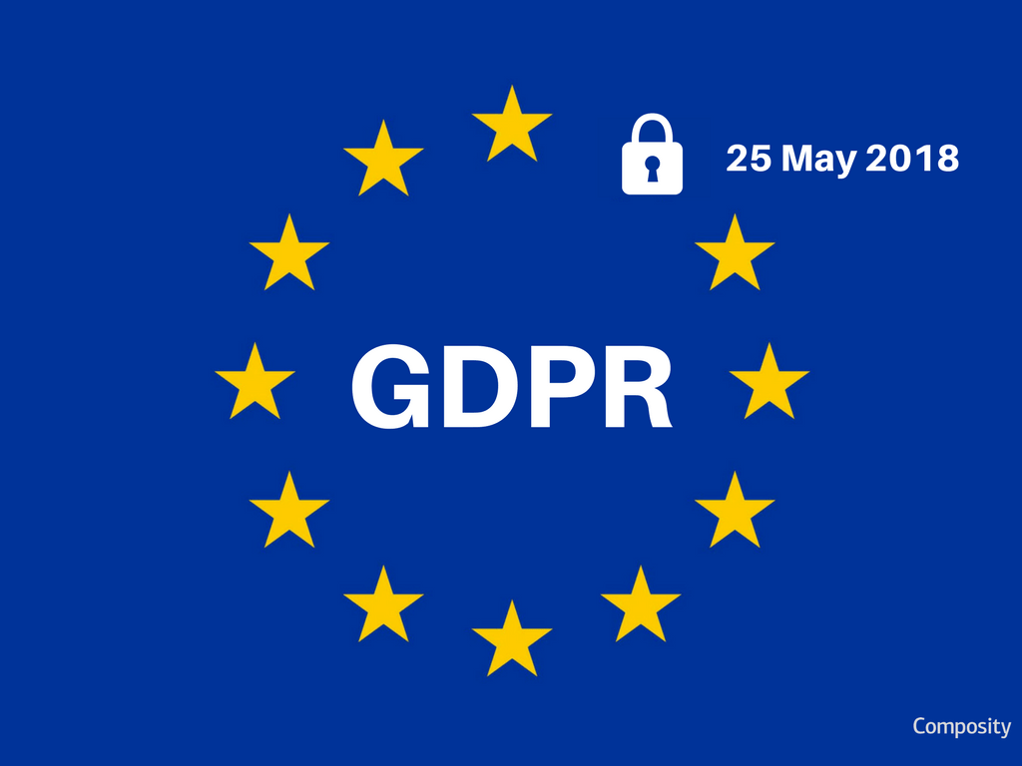
This law will give you more control over your personal information and helps you to understand how your information is used

We have a new privacy and data protection policy

This policy explains how we use, and protect any personal information we collect about you to provide the best service possible

More information about GDPR can be found on our website, including our Privacy and information notice and our cookies policy  This can be found on our ‘Home’ page | www.thebefriendingscheme.org.uk
If you have any questions, please contact The Befriending Scheme, who will be more than happy to help | Call us on:  01787 371 333  Write to us at:  The Befriending Scheme  1 The Croft  Sudbury  Suffolk  CO10 1HN  Email us at:  info@thebefriendingscheme.org.uk
TBS is registered with the ICO under the Data Protection Act 1998, under number ZA150156

Our company number is 03599476

